**DPS STS SCHOOL EXTENDED MATHEMATICS GRADE 9 WORKSHEET ON GRAPHS**

**1.**

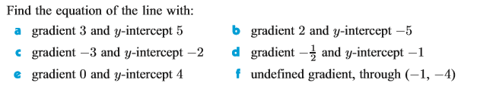

**2.**

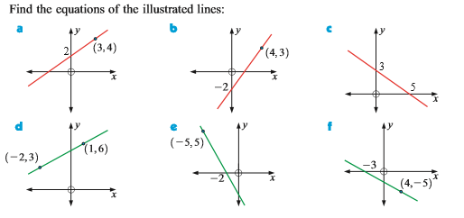

**3.**

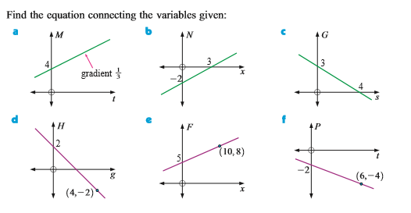

**4.**

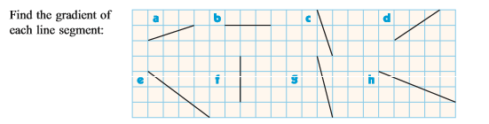

**5.**



**6.**

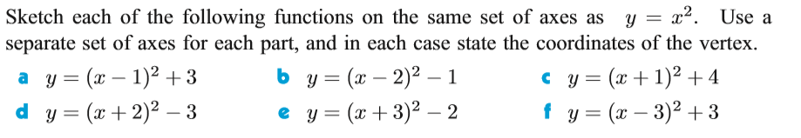

**7.**

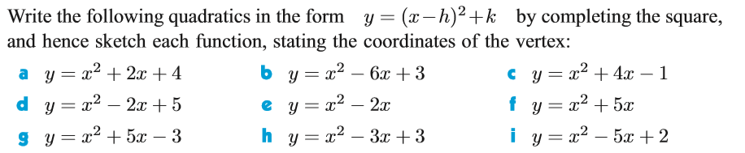

**8.**

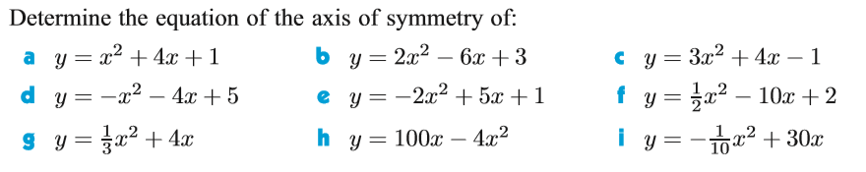

**9.**

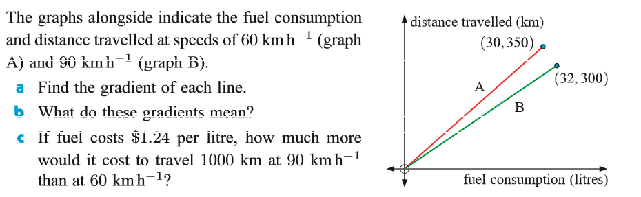

**10.**

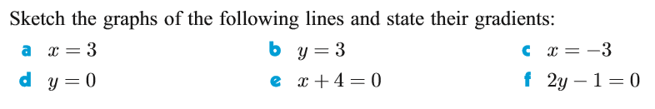

**11.**

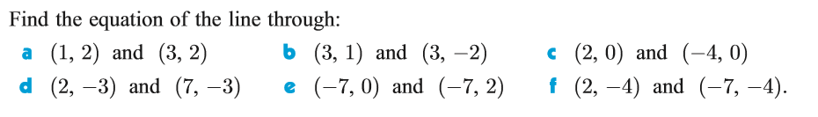

**12. **

**13.**

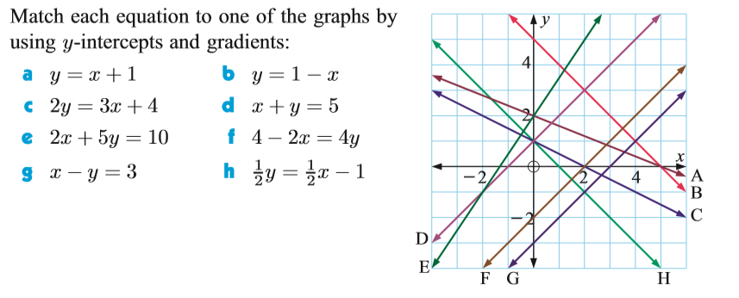

**14.**

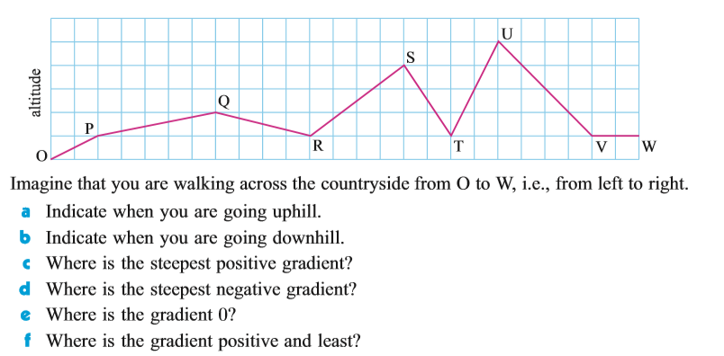

**15.**

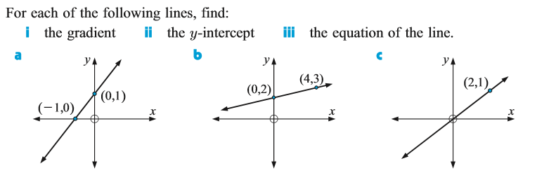

**16.** Find the solutions for the following functions by using graphical method. and

**17.** On the same grid draw the graphs for following functions and observe the consequences for all the drawn graphs.

**(a)**

**(g)**

**18.**

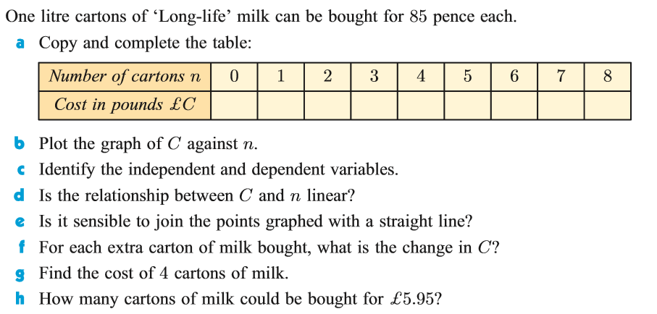

**19.**

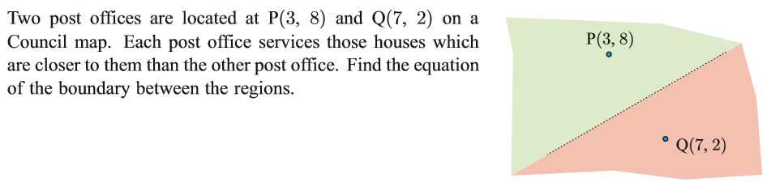

**20.**

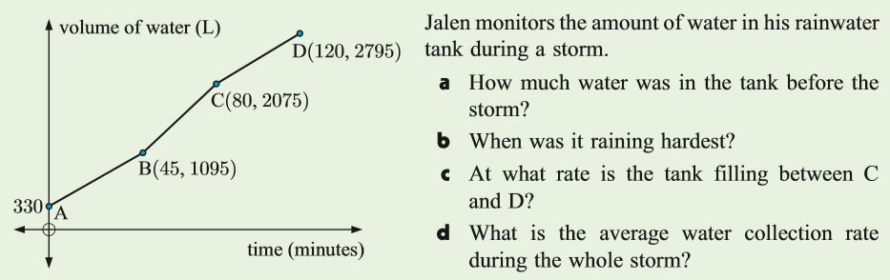

**21.**

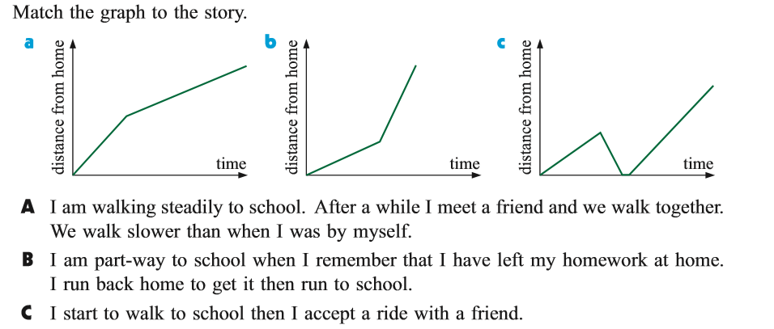

**22.**

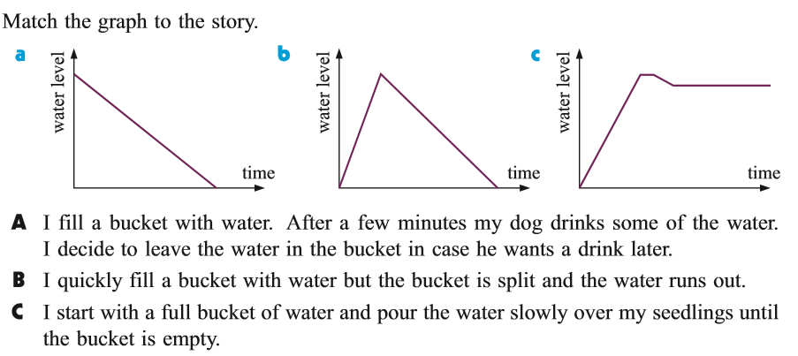

**23.**

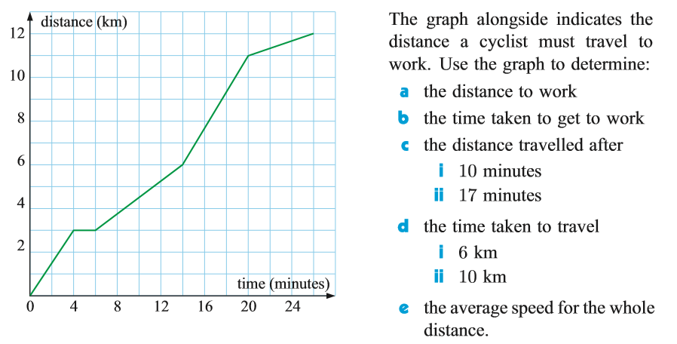

**24.**

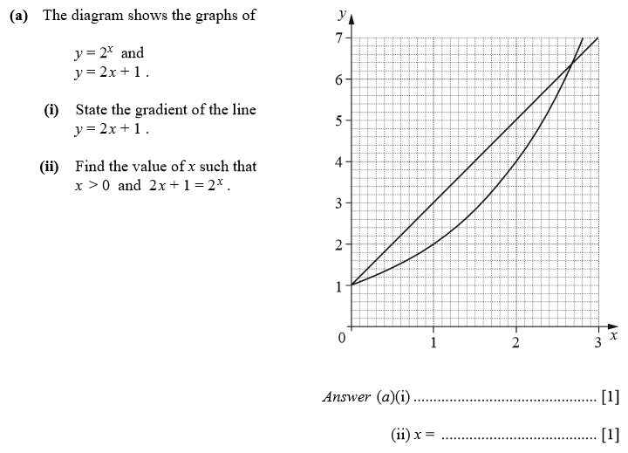

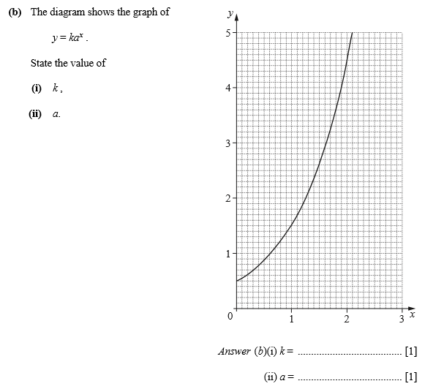

**25.**

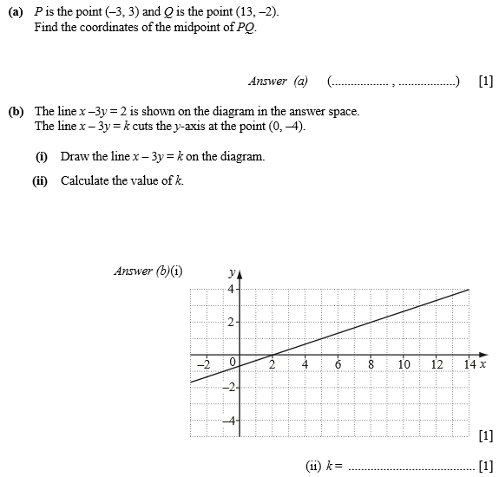

**26.**

[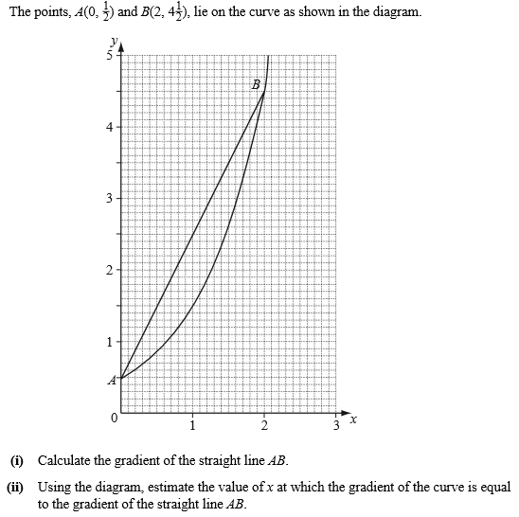](https://drive.google.com/file/d/1PWfkVgUuoSilTEunEeS1e2HzdfbFFwvw/view?usp=drivesdk)

**27.** On the same grid draw the graphs for following functions and observe the consequences for all the drawn graphs.

**(a)**

**(g)**

**THANKS FOR YOUR SINCERE WORKS ON THESE PROBLEMS**